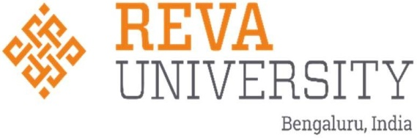

**9th International Conference on**

**11th Sustainable Materials & Practices for Advancements in Civil Engineering (SMPACE-2025)**

13th& 14th August, 2025

**About Conference**

The conference theme, **"Sustainable Materials and Practices for Advancements in Civil Engineering" (SMPACE – 2025)**, highlights the critical need for innovation and environmental responsibility in infrastructure development. This theme focuses on integrating eco-friendly materials and sustainable methods to drive progress in civil engineering. Scholars, engineers, and policy makers will gather to discuss cutting-edge advancements that promote resilience, efficiency, and durability in construction practices. Key topics include the use of recycled materials, energy-efficient designs, and innovative technologies to reduce the environmental impact of infrastructure.

The conference emphasizes interdisciplinary collaboration, fostering the exchange of ideas and strategies for sustainable solutions. Participants will explore ways to balance human development with ecological preservation, ensuring the longevity and functionality of structures. Presentations and discussions will delve into green construction practices, renewable materials, and advanced engineering techniques to create a positive impact on the environment.

SMPACE – 2025 aims to inspire the adoption of sustainable approaches in civil engineering, contributing to a greener and more resilient built environment. The event offers a platform for sharing research, developing best practices, and building connections that will shape the future of eco-conscious infrastructure. We hope all attendees find the conference both enriching and memorable, as they work together towards a sustainable future.

**Who can Participate**

Academicians, Research scholars and Postgraduate students from various universities and institutions, working professionals from industry and R&D organizations across the country are invited to participate and submit the articles.

|  |  |
| --- | --- |
| **Chief Patron**  **Dr. P. Shyama Raju**  Chancellor, REVA University  **Dr. Umesh S Raju**  Pro Chancellor, REVA University  **Patrons**  **Dr.R W Alexander Jesudasan**  Rector, REVA University  **Dr. Sanjay R. Chitnis**  Vice Chancellor, REVA University  **General Chair**  **Dr.Rajashekhar C. Biradar**  Pro Vice Chancellor, REVA University  **Dr. K. S. Narayanaswamy**  Registrar, REVA University  **Co- General Chair**  **Dr. Raghu C N**  Dean, Engineering & Technology, REVA University  **Dr. Diwakar B P**  Dean, Research and Innovation, REVA University  **Chairman-SMPACE-2025**  **Dr. Bhavana B**  Associate Professor & Director  REVA University,Bangalore  **Guest of Honour**  **Prof. K S Nanjunda Rao**  Chief Research Scientist  Department of Civil Engineering  Indian Institute of Science  Bangalore  **Conveners**  **Dr. Chunchu Balarama Krishna**  Associate Professor, School of Civil Engineering,  REVA University, India  **Dr. Avinash HT**  Assistant Professor, School of Civil Engineering,  REVA University, India  **International and National Advisory Board**  • Dr. Shamsher Bahadur Singh,  Professor of Civil Engineering Department, BITS,  Pilani, India.  • Dr. Ramachandra .V,  Principal Advisor, UltraTech (India), & Consultant  Professor -RASTA  • Dr. V. Srinivas,  Principal Scientist, CSIR, Chennai, India.  • Dr. Krishna R. Reddy,  Professor, University of Illinois at Chicago842  West Taylor Street, Chicago, Illinois 60607, USA  •Praveen Kumar M. C  Chief Executive  Samanvaya Infra Engineering Services, Bengaluru  •Hassan Rajasheker Girish  CEO and MD, Girish Ventures  Bengaluru  •Dr G Kavitha  Associate Professor& Head  RASTA Center for Road Technology  •Dr. Reshmi Devi T V  Associate Professor  BMSCE College of Bengaluru  **Internal Advisory Committee**  • Dr. Sunil Kumar Tengli  Professor, School of Civil Engineering, REVA  University, India  • Dr. M A Nagesh  Professor, School of Civil Engineering, REVA  University, India  •Dr. Sumant Kulkarni  Professor, School of Civil Engineering,  REVA University, India | **Organizing Committee**  • Mr. Prashanth N  SOCE, REVA University, India  • Mr. Amaranatha G A  SOCE, REVA University, India  • Mrs. Minakshi Mishra  SOCE, REVA University, India  **Publicity Committee**  •Dr. S Srikanth Reddy  SOCE, REVA University, India  • Dr. Kannam Praveen  SOCE, REVA University, India  • Dr. Sanjay Raj A  SOCE, REVA University, India  **Technical Committee**  • Dr. Avinash H.T  SOCE, REVA University, India  • Dr. Sanjay Raj A  SOCE, REVA University, India  • Dr. Sumant Kulkarni  SOCE, REVA University, India  • Dr. Kanimozhee  SOCE, REVA University, India  • Mrs. Pavithra M P  SOCE, REVA University, India  **Website & Branding Committee**  • Mr. Jayachandra  SOCE, REVA University, India  • Mr. Harish Sagar  SOCE, REVA University, India  **Hospitality Committee**  • Dr. Kannam Praveen  SOCE, REVA University, India  • Mr. Amaranatha G A  SOCE, REVA University, India  • Dr. Pradeep Kumar B K  SOCE, REVA University, India  • Dr. Ajaybhaskar Reddy  SOCE, REVA University, India  • Mr. Nanjunda K N  SOCE, REVA University, India  **Transportation & Accommodation Committee**  • Mr. Amaranatha G A  SOCE, REVA University, India  • Mr. Madhu K A  SOCE, REVA University, India  • Mr. Venkatesh Wadki  SOCE, REVA University, India  • Mr. Karthik Kumar  SOCE, REVA University, India  • Mr. Harish Sagar  SOCE, REVA University, India  **Registration Committee**  • Mrs. Minakshi Mishra  SOCE, REVA University, India  • Mrs. Pushpa Lumina  SOCE, REVA University, India  • Mrs. Preethi  SOCE, REVA University, India  • Ms. Lovely Sabat  SOCE, REVA University, India  •Mr. Sreenatha  SOCE, REVA University, India  • Mr. Srinidhi S U  SOCE, REVA University, India  **Report and Documentation committee**  •Dr. Bharath Simha Reddy  SOCE, REVA University, India  • Dr. Mehar Babu Ravula  SOCE, REVA University, India  •Dr. Vigneswaran  SOCE, REVA University, India  •Ms. Bhanu Suresh  SOCE, REVA University, India  **Finance and Account Committee**  • Mr. Prashanth N  SOCE, REVA University, India  • Mr. Rakesh H  SOCE, REVA University, India |

**Call for Papers**

The conference will have plenary lectures followed by parallel sessions. Plenary lectures will be delivered by eminent personalities of repute, to introduce the theme of the conference. Conference will provide a platform to students, researchers, young aspiring engineers, academicians to present their research ﬁndings of their respective domains of knowledge and share ideas. Only selected papers will be published with publication charges in scopus indexed conference proceedings after review from publishers.

**Important Dates**

Last date for submission of abstract 11th April, 2025

Last date for acceptance of abstract 5th May, 2025

Last date for submission of full-length paper 5th June, 2025

Last date for acceptance of full-length paper 5th July, 2025

Last date of registration 20th July, 2025

**REGISTRATION FORM**

**Sustainable Materials and Practices for Advancements in Civil Engineering (SMPACE – 2025)**

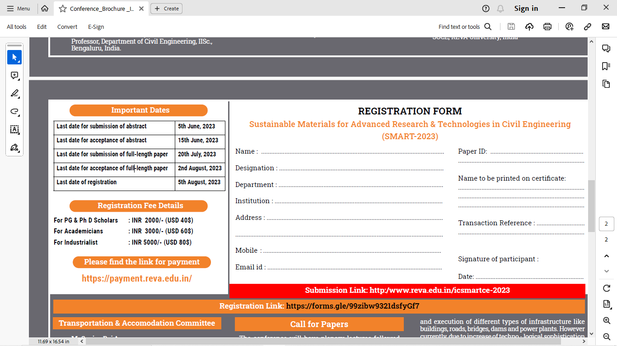

Submission Link:

Registration Link:

**Registration Fee Details**

For students & PhD Scholars: INR 1500/- (USD 18$)

For Academicians: INR 2000/- (USD 23$)

For Industrialist: INR 2500/- (USD 29$)

**About REVA University**

REVA University is a State Private University established in Karnataka State under the Government of Karnataka Act No. 13 in the year 2012 in Bengaluru, the IT capital of India. REVA University, recognised by the University Grants Commission (UGC) and approved by the All India Council for Technical Education (AICTE), has an A+ grade from NAAC.

REVA University prides itself in contributing to every student’s holistic development. The University currently offers 37 full- time undergraduate programmes, 28 full-time postgraduate programmes, 19 Ph.D. programmes, and certification and diploma programmes. The University offers programmes in Engineering, Architecture, Science and Technology, Commerce, Management Studies, Law, Arts & Humanities, and Performing Arts. Courses are offered in Certificate/Diploma and Post Graduate Diploma too. REVA University facilitates research leading to a Doctoral Degree in all disciplines. The programmes offered by REVA University are well-planned and designed based on methodical analysis and research with emphasis on knowledge assimilation, practical applications, hands-on training, global and industrial relevance, and their social significance.

Teachers and instructors with illustrious academic experience are the architects of the meticulously designed curriculum and program modules offered at REVA University. They come with industrial exposure and experience that often translates through their teaching, thus bridging the gap between the industry and academia. REVA University has an updated, ever-evolving collection of books, journals, and digital content in the library with the latest IT infrastructure that ensures students have information at their disposal. The lush green campus, state-of-the-art laboratories, custom designed classrooms to enable seamless learning, and world-class indoor and outdoor sports facilities make REVA University the most preferred university among students and MNCs that visit the campus for placements.

**About The School of Civil Engineering**

The School of Civil Engineering is headed by highly experienced Professor and is supported by well qualiﬁed faculty members. The school has state-of-the-art classrooms and well-equipped laboratories. It offers B.Tech in Civil Engineering and M.Tech programs in Computer Aided Structural Engineering, Transportation Engineering & Management and Construction Technology & Management. The school also has research program leading to doctoral degree. The curriculum of both graduate and postgraduate degree programs have been designed to bridge the gap between industry – academia and hence they are industry application oriented. Civil Engineering teaching was limited to planning, analysis, design and execution of different types of infrastructure like buildings, roads, bridges, dams and power plants. However, due to increase of technological sophistication and demand for higher living standards, geared up by economic growth and concerns about environmental impact have changed the scope of Civil Engineering. The REVA University offers Civil Engineering Programme to produce quality engineers who are effective and efﬁcient in problem solving and providing economical and sustainable infrastructural solutions.

**Research Areas**

**Materials, Structures and Construction**

• Advances in Science and Technology of Cement, Admixtures and Concrete.

• Concrete with Recycled Materials.

• Sustainability of Concrete and Durability of Concrete.

• Structural Health Monitoring.

**Geotechnical, Geosynthetic and Geotextile Applications**

• Soil Stabilization Material and Methods.

• Reinforced Earth Structures and Materials.

• Ground Investigation and Ground Risk Management.

• Ground Improvement Techniques.

**Water Resources and Environmental Pollution**

• Water Resources Planning and Management.

• Ground Water Modeling & Recharge.

• Water and Wastewater Treatment.

• Municipal Solid Waste Characterization and Management.

**Transportation, Surveying, and Construction Management**

• Material Characterization.

• Pavement Materials Evaluation.

• Application of Remote Sensing and GIS.

• Time and Cost Optimization in Project Management.

* Multidisciplinary Perspectives in Sustainable Infrastructure

**For any queries please contact**

**Conference Mail ID:**

**smpace2025@reva.edu.in**

**Dr. Chunchu Balarama Krishna,**

**REVA University, India**

**Email ID: chunchubalarama.krishna@reva.edu.in**

**Mobile: +91- 9704143589**

**Dr. Avinash HT,**

**REVA University, India**

**Email ID: avinash.htalkeri@reva.edu.in**

**Mobile: +91- 9481643343**

**www.reva.edu.in**